Online Info Day Meeting Minutes
WP2/ Task 2.2 / v1

May 26, 2020

DEVELOPMENT OF A MASTER PROGRAMME IN THE MANAGEMENT OF INDUSTRIAL ENTREPRENEURSHIP FOR TRANSITION COUNTRIES
610198-EPP-1-2019-1-ES-EPPKA2-CBHE-JP

Table of Contents

Attendants 2
Minutes 3
WP1. General description (P1. USC) ......4
WP2. Market needs analysis: Preliminary a quantative results of the labour market in Kazakhstan 4

Attendants
 | P# | Acronym | Name
1 | P1 | USC | Ángel Duarte Campos
2 | P2 | Ayeconomics | Aizhan Samambayeva
3 | P2 | Ayeconomics | Yolanda Pena Boquete
4 | P9 | KEUK | Oxana Bezler
5 | P9 | KEUK | Karina Nevmatulina
6 | P9 | KEUK | Olessya Zhidkoblinova
7 | P9 | KEUK | Yevgeniya Puntus
8 | P9 | KEUK | Dinara Sergaliyeva
9 | P9 | KEUK | Ainura Omarova
10 | P9 | KEUK | Akylbek Imangaliev - student
11 | P9 | KEUK | Yekaterina Yurkiv – student (with Bezler O. from PC)
12 | P9 | KEUK | Anastasiya Krikunova - student
13 | P9 | KEUK | Yerlan Zhailauov - regional employer
14 | P14 | ECBP | Zhanargul Kulmagambetova

Minutes
The online Info Day meeting took place on the 26th of May 2020. The aim of Info Day is the general presentation of the project to the main stakeholders that will participate in Delphi Survey of the Market Needs Analysis.
Ayeconomics presented the preliminary results of a quantitative analysis of the labour market in Turkmenistan. The next step is to receive feedback and comments from stakeholders for further improvements. The final version of the presentation is available in Slack application.
The main issues and action points that were discussed are described below.

WP1. Project Launch: General presentation of the project (P1. USC) Ángel Duarte Introduced the main Project activities and tasks allocated.
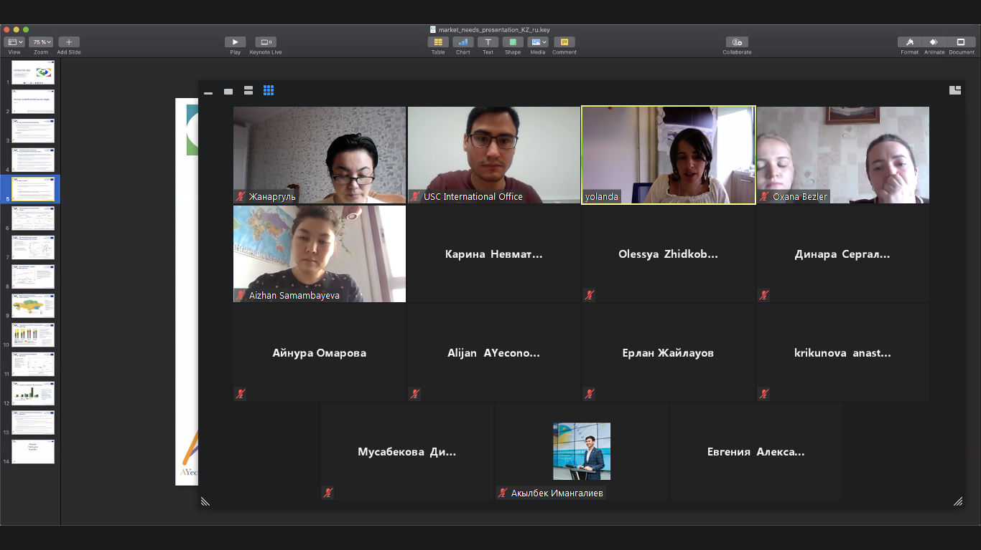

WP2. Market needs analysis (AYeconomics)
A detailed working plan of Market Needs Analysis, its aim and motivation were presented.
The presentation of the labour market in Kazakhstan was presented by Aizhan Samambayeva from Ayeconomics.
The market needs analysis consists of one side of quantitative analysis based on the statistical data, constructing labour market and industrial indicators to analyse market characteristics from the supply and demand side. At the macroeconomic level, the analysis will comprise (a) the national and regional perspectives and urban data (employment and unemployment data, wage dynamics and regional migration) and (b) the sectoral perspective (trends in the sector, industrial output, job vacancies, wage dynamics and employment/unemployment data). At the microeconomic level, the analysis will encompass (a) the university perspective on the supply side (graduates by gender, geography, age and work experience) and (b) the employer perspective on the demand side (number and types of enterprises, growth rate and wage).
The research involves a DELPHI analysis for assessing the skills that will be required in the future (through an online survey for key experts). This requires a list of stakeholders to be compiled (policymakers, firms, HEIs, research institutions, associations…). The survey will collect data on the share of employees facing skill shortages, hard-to-fill vacancies, types of skills that employers cannot find and training needs).
